Maxwell Maia Assignment 7

Q1

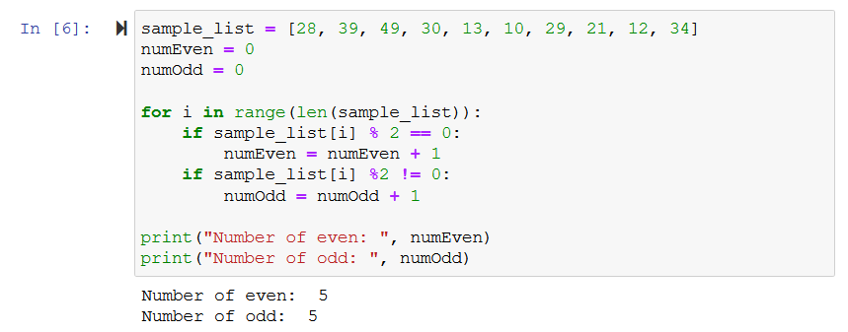Q2

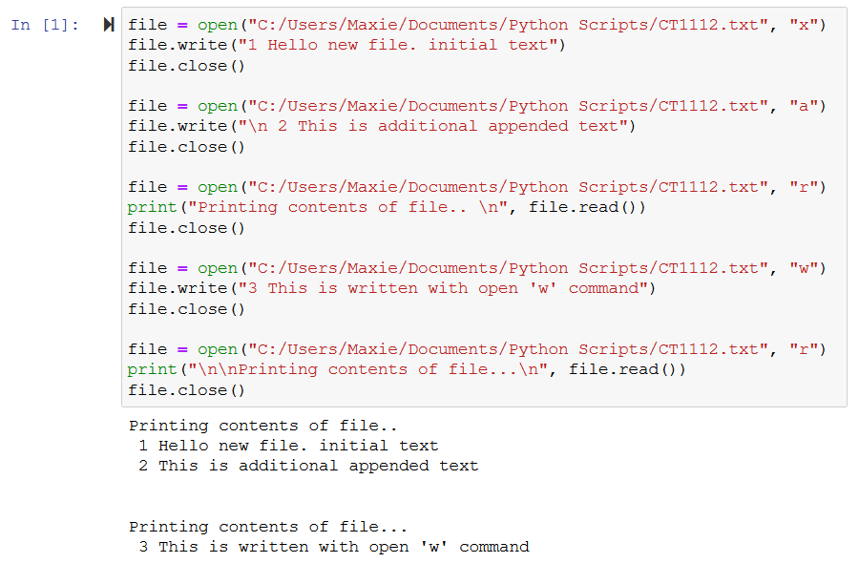Q3

Q4

